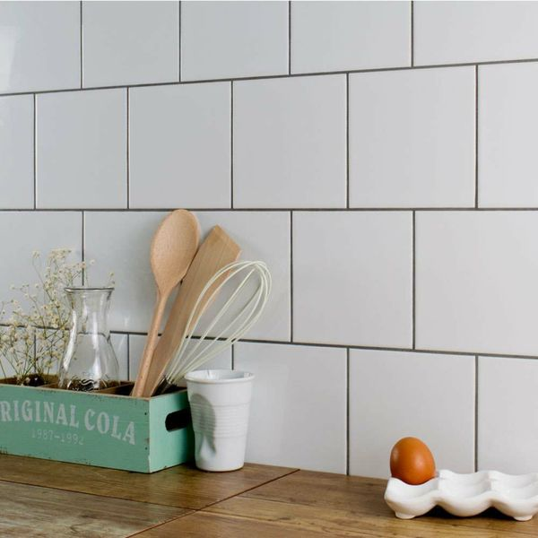

Innocence Smooth Gloss White Wall Tiles: <https://www.wallsandfloors.co.uk/innocence-whites-white-smooth-gloss-150x150-tile>

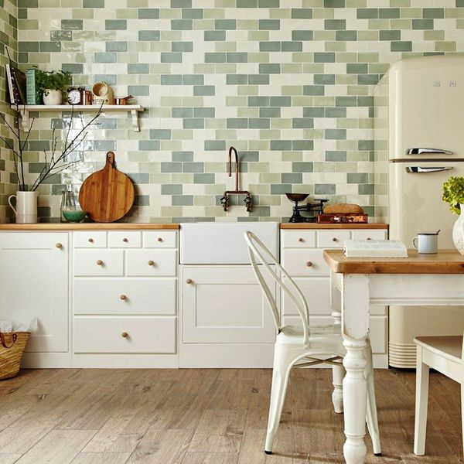

Cedar Green Rustic Metro Tiles: <https://www.wallsandfloors.co.uk/rustic-metro-cedar-tile>

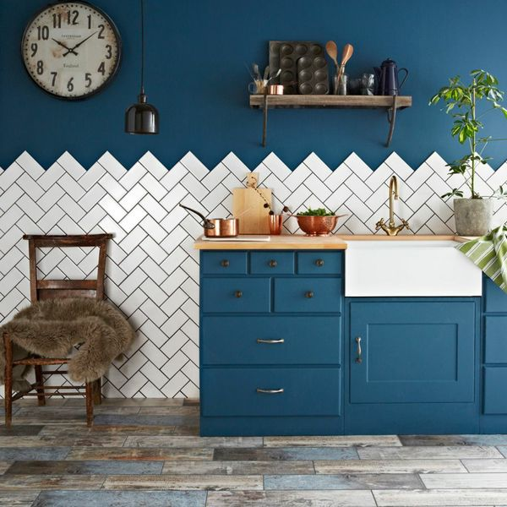

Bastille White Smooth Crackle Mini Metro Tiles: <https://www.wallsandfloors.co.uk/antique-smooth-crackle-metro-tiles-bastille-white-crackle-metro-tiles>

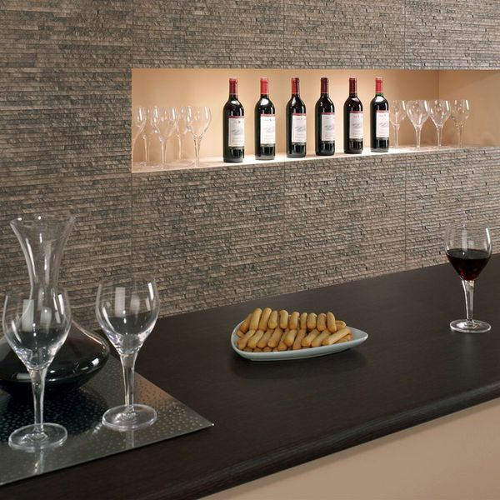

Waterfall Textured Marron Split Face Tiles: <https://www.wallsandfloors.co.uk/waterfall-tiles-marron-tiles>

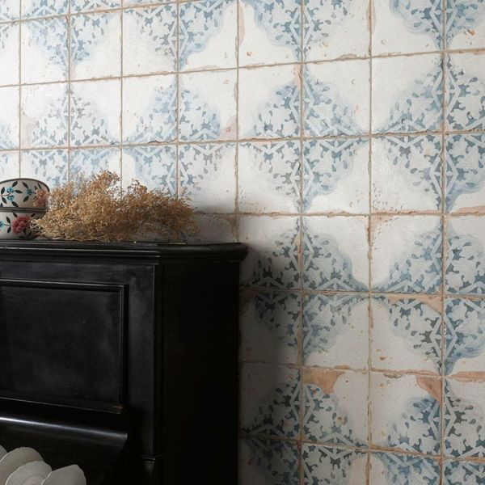

Vecchio Diamante Indigo Tiles: <https://www.wallsandfloors.co.uk/indigo-modello-vecchio-diamante-indigo-tiles>

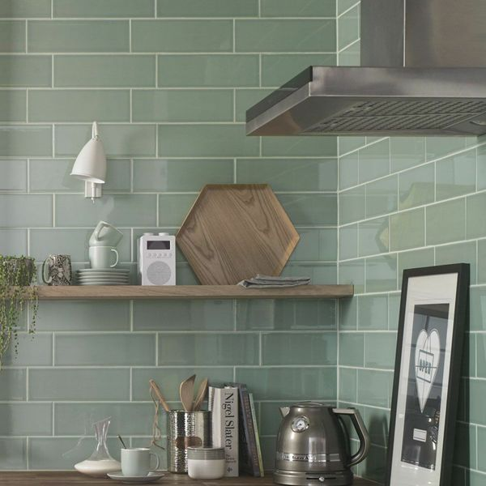

Aquarelle Pistachio Green Tiles: <https://www.wallsandfloors.co.uk/pistachio-aquarelle-tiles>